Individual guest room reservation request
‘WEI International European Budapest Conference’
22-24 June, 2014

Please return to Mercure Budapest Korona to the banquet sales office:
Kecskeméti u. 14
H-1053 Budapest
Hungary
Tel: +36-1-486-8892
Fax: +36-1-318-3867

H1765-sb4@accor.com

THE DEADLINE FOR MAKING RESERVATIONS IS 31 March, 2014.

Please make the following hotel reservation:
- Single standard room: EUR 99,- □
- Double standard room: EUR 109,- □
- Privilege supplement per room per night: EUR 20,- □
Smoking: □ Non-smoking: □
The rate given is quoted per room, per night and included of 18 % VAT, of 4% city tax and the buffet breakfast.
Arrival date:............................................. Departure date:..................................
Number of guests in the reserved room:……….person(s)
Name:.....................................................................................................................................
Address:.................................................................................................................................
...............................................................................................................................................
Phone:............................................................Fax:..................................................................
Payment for accommodation should be made directly to the hotel. In order to guarantee your room please supply the following credit card information and the copy of your credit card.
Without these details we cannot accept and confirm the reservation.
Credit card type:............................................................................................
Credit card number:.......................................................................................
Expiry date:....................................................................................................
"I guarantee this room reservation with my credit card. I agree that in case of non-arrival, the whole stay room rate will be charged to my credit card, unless the reservation has been cancelled and the cancellation confirmed by fax 48 hours before the arrival date."

Date:...............................................................................................................
Signature/authorisation:.................................................................................
CONFIRMATION Hotel Mercure Budapest Korona by:
Reservation number:
Date of confirmation:
Location:
The 4 star Mercure Budapest Korona Hotel is located in the downtown at the entrance of the new Main Street of Budapest. Our hotel is well reachable by public transport and has an easy access from Budapest Ferihegy airport. You can reach different cultural sights, spas, restaurants and business centres with a few minutes walk. Discover Budapest - the city of senses - and enjoy every minutes of a special and unforgettable stay in our hotel. There is an onsite parking possibility.

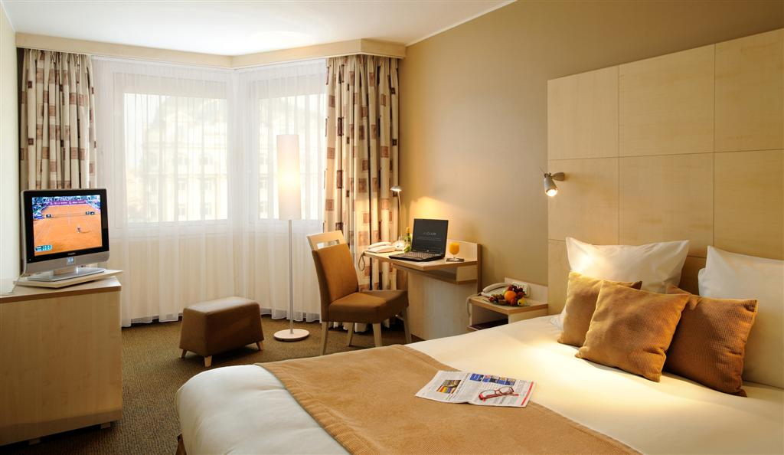
Accommodation:
We offer our guests 421 air-conditioned, comfortable and bright rooms equipped with smoke alarm, LCD Screen, WiFi, wired Internet, phone, minibar, in-room safe, bathroom with shower or shower/tub combination and hairdryer. Beside the Standard Rooms we provide Privilege Rooms. We have also special rooms for disabled guests.

Privilege rooms:
Choose our Privilege Room for the exclusive features, take a break and enjoy the following wide range of special offers like:
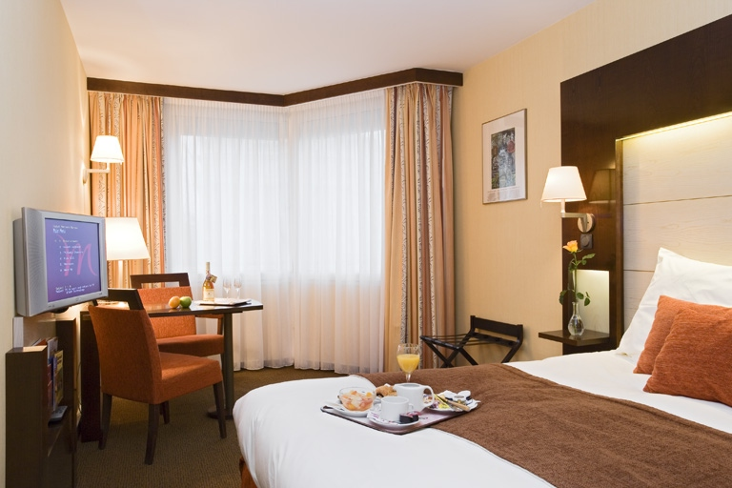
  - Tea and coffee making facility in the room
  - Free WiFi Internet access in the room
  - Bathrobe, slippers
  - Full range of amenities
  - Magazines and newspapers
  - Complimentary bottle of mineral water upon arrival
  - Privilege breakfast in the Bridge Bar from Tuesday to Friday

Tokaj Restaurant & Bridge Bar & Lobby Bar:
We await your guests in our well-known Tokaj Restaurant, where you can taste the masterpieces of the famous traditional Hungarian cuisine with the best of Tokaj wines. In a friendly atmosphere with professional service and a wide drink selection you can spend your free time in our Bridge Bar or Lobby Bar.

